RESOLUTION NO.__________

RE: CERTIFICATE OF APPROPRIATENESS UNDER THE
PROVISIONS OF THE ACT OF THE PENNSYLVANIA
LEGISLATURE 1961, JUNE 13, P.L. 282 (53
SECTION 8004) AND BETHLEHEM ORDINANCE NO.
3952 AS AMENDED.

WHEREAS, it is proposed to install murals at 321 Adams Street.

NOW, THEREFORE, BE IT RESOLVED by the Council of the City of Bethlehem that a Certificate of Appropriateness is hereby granted for the work.

Sponsored by: (s)

(s)

ADOPTED BY COUNCIL THIS DAY OF

(s)
President of Council

ATTEST:

(s)
City Clerk

HISTORIC CONSERVATION COMMISSION

CASE # 564– It is proposed to install murals at 321 Adams Street
OWNER/APPLICANT: Lehigh University/Michael DeCrosta

The Commission upon motion by Mr. Lousch seconded by Mr. Evans adopted the proposal that City Council issue a Certificate of Appropriateness for the proposed work described herein:
- The proposal to install murals at 321 Adams Street was presented by Michael DeCrosta.
- The mural panels will be ½” MDO sign board installed in three blind window openings with masonry screws into mortar joints.
- The two murals facing Adams Street will be approximately 39 ¾” x 74 ½”’ and 39 ¾” x 60 ½”. The one facing 4th St. will be approximately 39 ¾” x 60 ½”. There will be a ½’ +/- gap around panels.
- The murals will be a probably feature a skate boarder, a man and a woman, and a woman taking dog for a walk. The murals will be removed in 3-5 years when building is renovated.
- The proposed motion was unanimously approved.

CU: cu
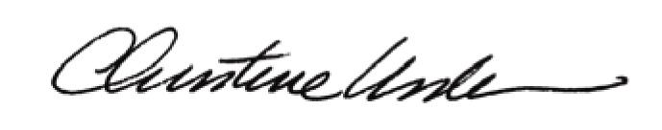

By:

Date of Meeting: August 17, 2015 Title: Historic Officer

